HealthyPhoton

Model：HT-1800
The Most Cost-effective
Open-path Laser Hygrometer
--Designed for Eddy Covariance Measurements

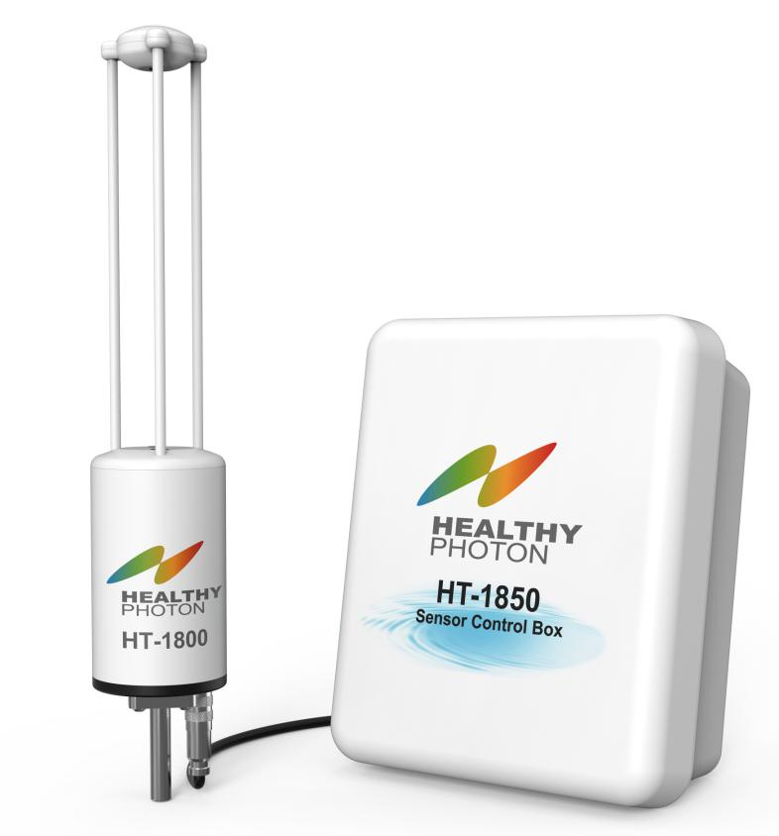

Date | Note
2020/08/01 | V1.0

Index

Index 2
1. Introduction 3
2. Features and Benefits 3
3. Specifications 4
4. Order Information 5

Introduction
In today's uneven distribution of water resources, more understanding of evapotranspiration (ET) can be of great help to water management. Among various techniques, eddy covariance is the most direct method of measuring ET. The required eddy covariance measurement system is based on a sonic anemometer and a highly sensitive hygrometer with fast response frequency (e.g. 10Hz).

HealthyPhoton is introducing the new HT1800 TDL (Tunable Diode Laser) Open-path Hygrometer designed for the eddy covariance method. Since the introduction of the HT8700E Open-path Ammonia Analyzer, we have gradually accumulated experiences in the development and application of instruments in the field of environmental monitoring. Out new HT1800 hygrometer has the open-path configuration that directly measures the moisture content of the atmosphere, ensuring the high accuracy and high speed of measurement. In terms of performance, the instrument fully satisfies the need in the eddy covariance method, and is indispensable in eddy covariance systems for ET analysis and flux corrections of other gas species.

Features and Benefits
- Light weight, low cost, easy installation and maintenance
- Ideal for eddy covariance and evapotranspiration measurements
- Open path configuration, with up to 20Hz measurement frequency
- Ultra-sensitive laser spectroscopy brings very low drift
- No cross-interference from CO₂ and other gas molecules
- No moving parts with strong vibration resistance
- Robust design for versatile field deployment
- Low power (10 W) that can be supplied by a solar panel

Specifications

Detection Technology | TDLAS (Tunable Diode Laser Absorption Spectroscopy)
RMS noise(1σ; 20Hz/10Hz/1Hz) | 7 ppm/ 5 ppm/ 2 ppm
Measurement Range | 0 - 60 mmol/mol or 0 - 60 pptv
User Interface | Windows based software
Output Data Rate | 20 Hz/10 Hz/ 1Hz user configurable
Operating Pressure | 70 - 110 kPa
Operating Temperature | -20°C ~ 50°C
Operating Humidity | 0 ~ 100% R.H. Non condensing
Data Communication | RS-232
Data Storage | On-board storage with SD card or any data loggers with RS-232 communication interface
Power Requirements | 10 - 30 VDC
Power Consumption | Typ. 10 W (max. 30 W at warm up )
Dimensions | Sensor Head: L450mm×ø90mm  Control Box: 34cm x 30cm x 15cm  TDL Cable: 3 meters (between sensor head and control box)  Power, RS-232, T/A Aux. Input: 3 or 5 meters
Weight | Sensor Head: ~2.5kg; Control Box: ~1.5kg
Environmental Adaptability | IP67

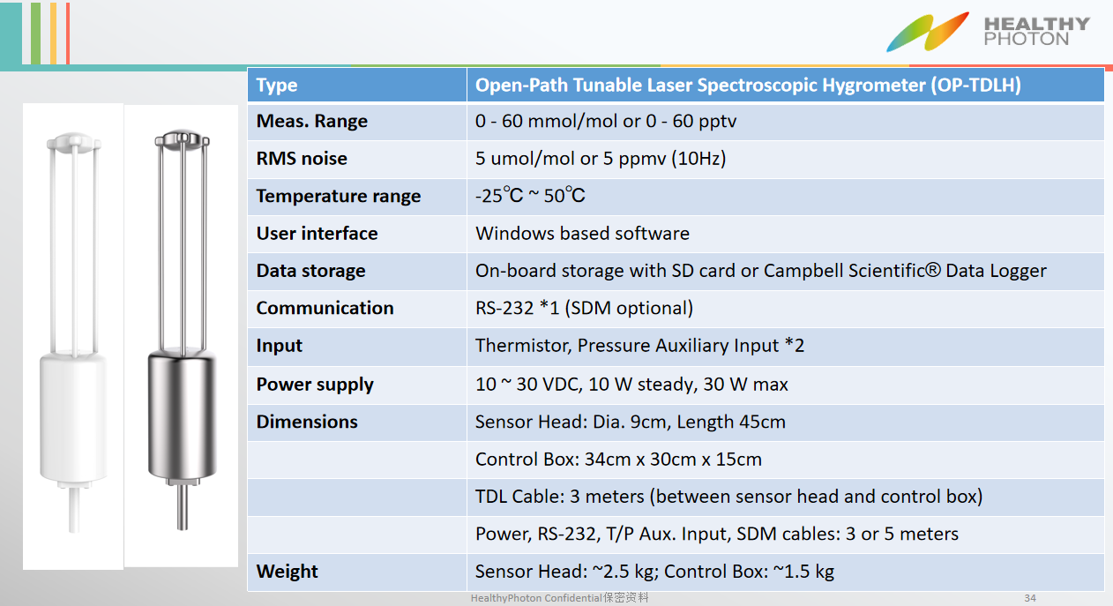

Order Information
Item | Part No. | Note
TDL sensor head | HT-1800
Sensor control box | HT-1850
External temperature sensor | HT-1850-001 | An external temperature thermistor is included for measuring ambient temperature outside of the HT-1850.
Power cable | HT-1850-002 | Used to connect the HT-1850 to a 20-28VDC power supply.
Sensor head control cable | HT-1850-003 | Connects the sensor head to the sensor control box.
Calibration accessory | HT-1800-001 | Contains a calibration shroud required for setting the zero and span of the HT-1800.
Mounting kit | HT-1850-004 | Structural fixture for fixing HT 1800, HT-1850 on flux observation tower or carrier.
Internal desiccant bottle | HT-1800-002 | The dehumidification chemicals used to remove water vapor in the sensor head. It must be replaced regularly according to the internal humidity instructions of the instrument.
Shipment box | HT-1850-005 | A precision instrument box for safe, shock-proof storage and transportation of HT-1800, HT -1850 and accessories.

